**Quickplot**

* The qplot() function is supposed to make the same sort of plots as ggplot(), but with simpler syntax.
* In practice, for more complex plots, it is probably more straightforward to use ggplot().
* Many of the arguments supplied to plot() (e.g. main, xlab, ylab etc) can be supplied to qplot().

## Motor Trend Car Road Tests

## This data set was extracted from the 1974 Motor Trend US magazine, and comprises fuel consumption and 10 aspects of automobile design and performance for 32 automobiles (1973–74 models).

(Source: Henderson and Velleman (1981), Building multiple regression models interactively. *Biometrics*, 37, 391–411)

**Simple histogram using quickplot**

The basic syntax of the command is

qplot(x.var,data=dataset.name)

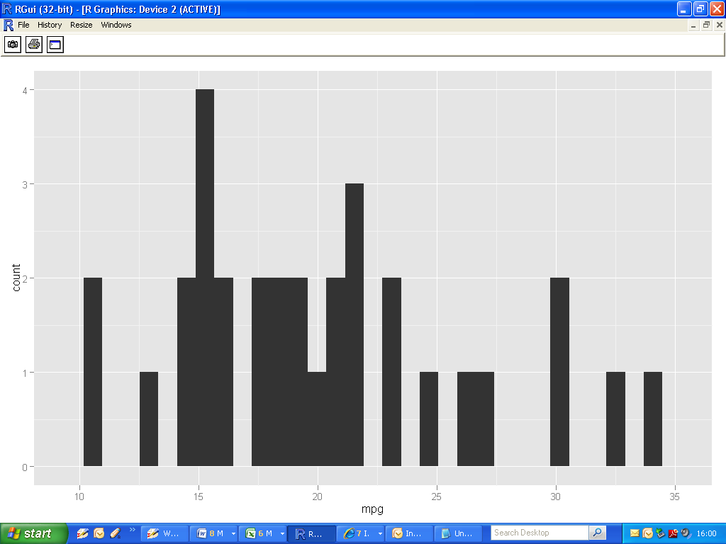

**Adjusting bin-width**

|  |
| --- |
| >  >qplot(mpg,data=mtcars, **binwidth=2**)  > |

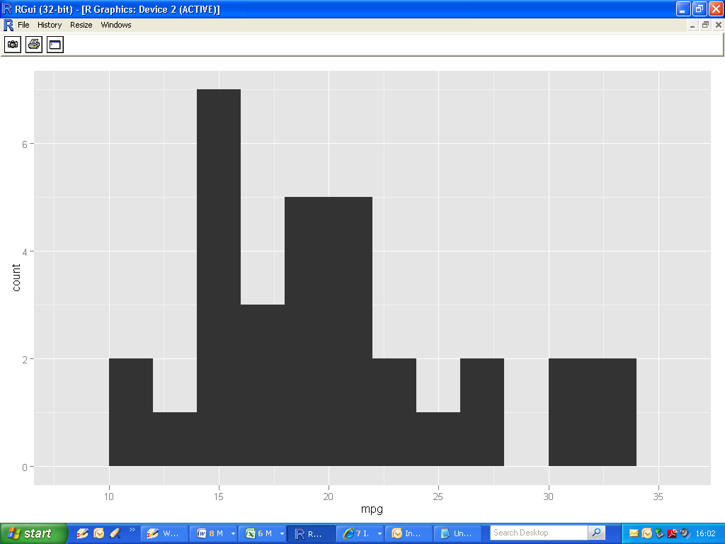

**Histogram geom**

|  |
| --- |
| > qplot(mpg,data=mtcars, **geom=c("histogram")**, binwidth=2) |

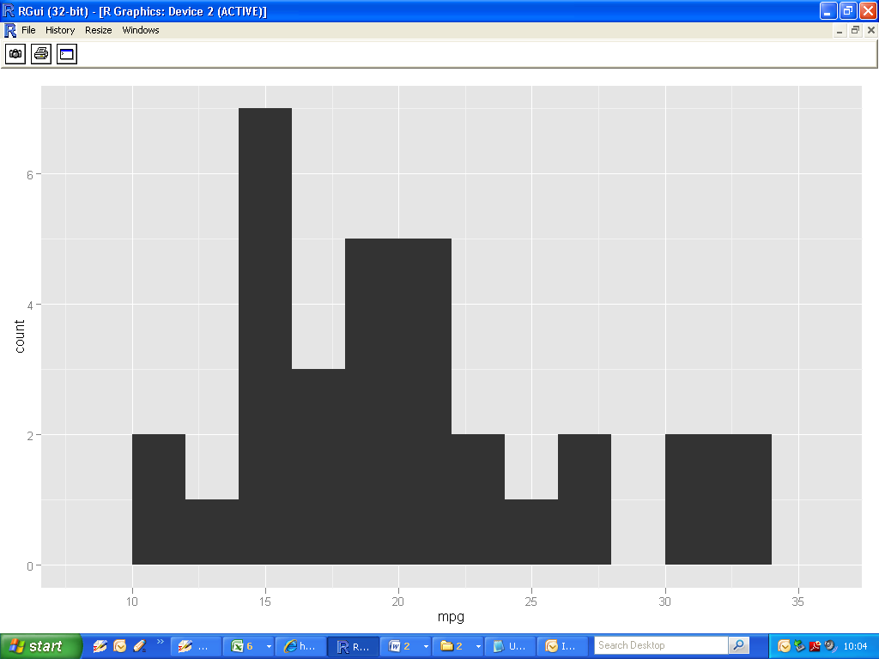

**Simple scatterplot using quickplot**

The basic syntax of the command is

qplot(x.var,y.var,data=”dataset.name”)

* Dataset name : mtcars
* X variable: Miles Per Gallon (mpg)
* Y variable: Weight (wt)

|  |
| --- |
| >  > qplot(mpg,wt,data=mtcars)  > |

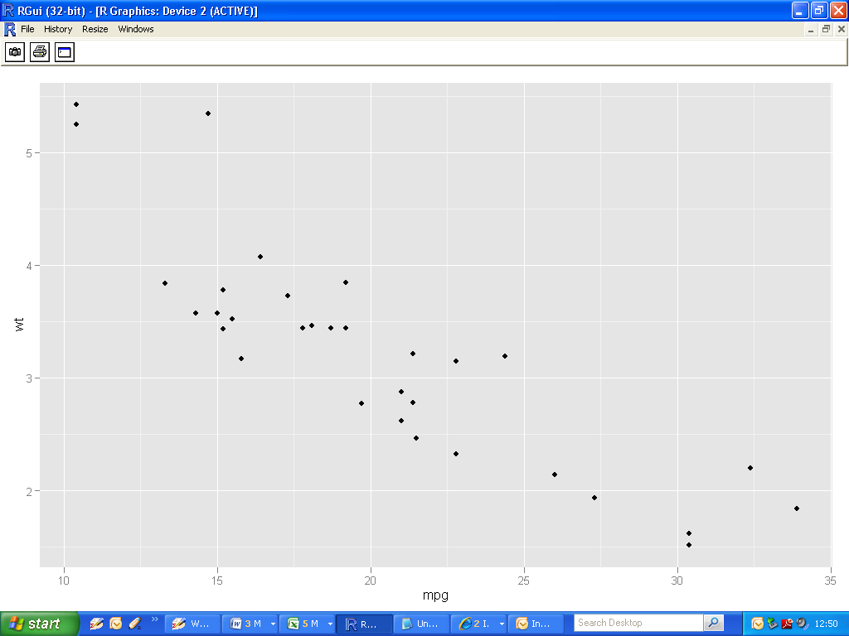

Immediately noticeable:

* Glyph is little black dot
* Grey background with white gridlines (This is called a “theme”. More later)

**Subsetting**

Those familiar with the mtcars dataset would be aware of other (categorical ) variables. For example

* cyl : number of cylinders (4, 6 or 8?)
* vs : ( binary variable)
* am : Transmission (0 = automatic, 1 = manual)

|  |
| --- |
| >  >qplot(mpg,wt,data=mtcars, **colour=am**)  > |

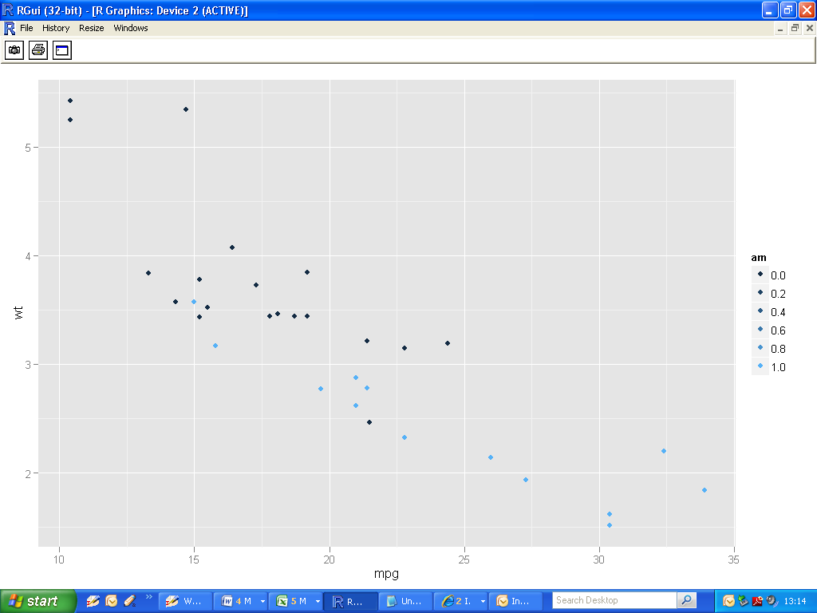

* Divide the scatterplot into two clusters (automatic and transmission). Useful visual aid.
* However, notice the legend – we have 6 categories for the variable “am” (which is in fact binary). Need to fix this; use the function factor().

|  |
| --- |
| >  >qplot(mpg,wt,data=mtcars, **colour=factor(am)**)  > |

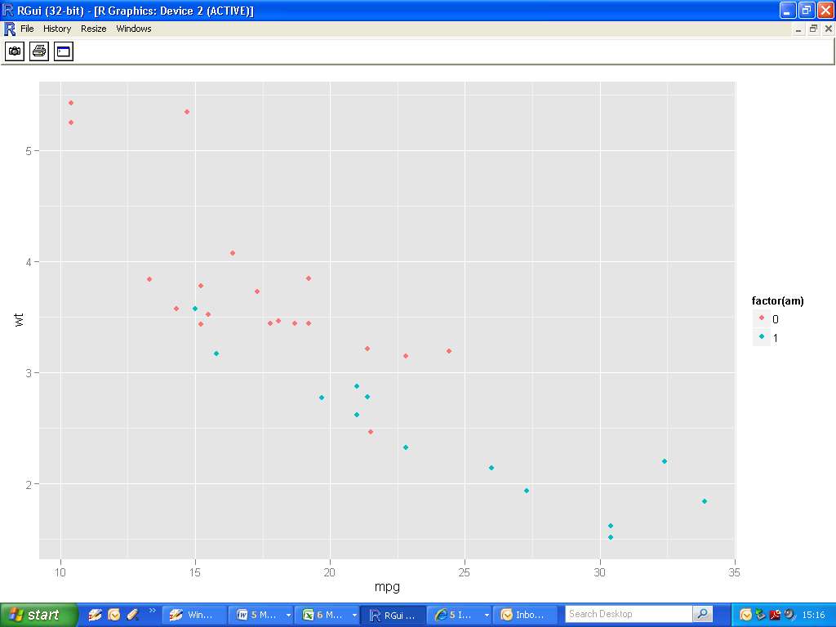

**Using different aesthetic mappings : size**

|  |
| --- |
| > qplot(wt, mpg, data=mtcars, **size=qsec**)  > |

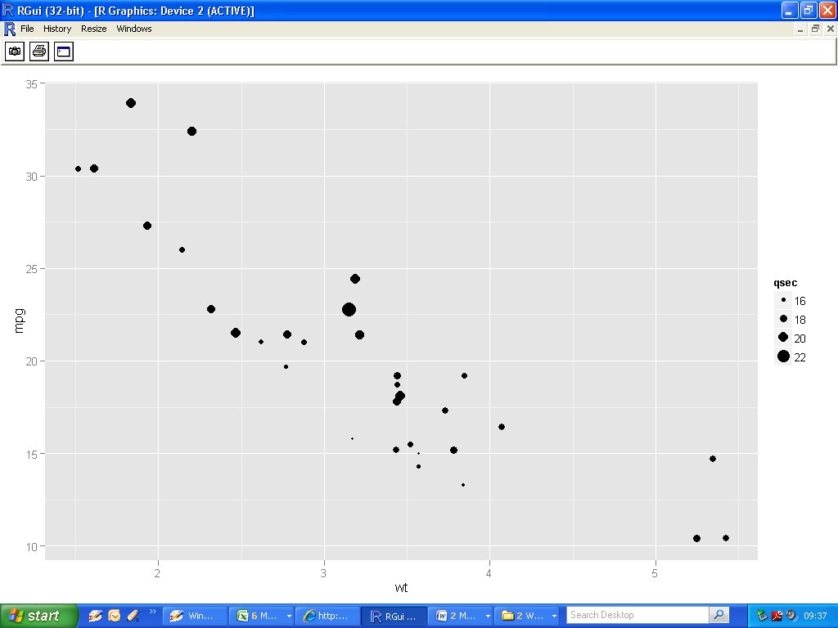

**Using different aesthetic mappings : shape**

|  |
| --- |
| > qplot(wt, mpg, data=mtcars, **shape=factor(cyl)**)  > |

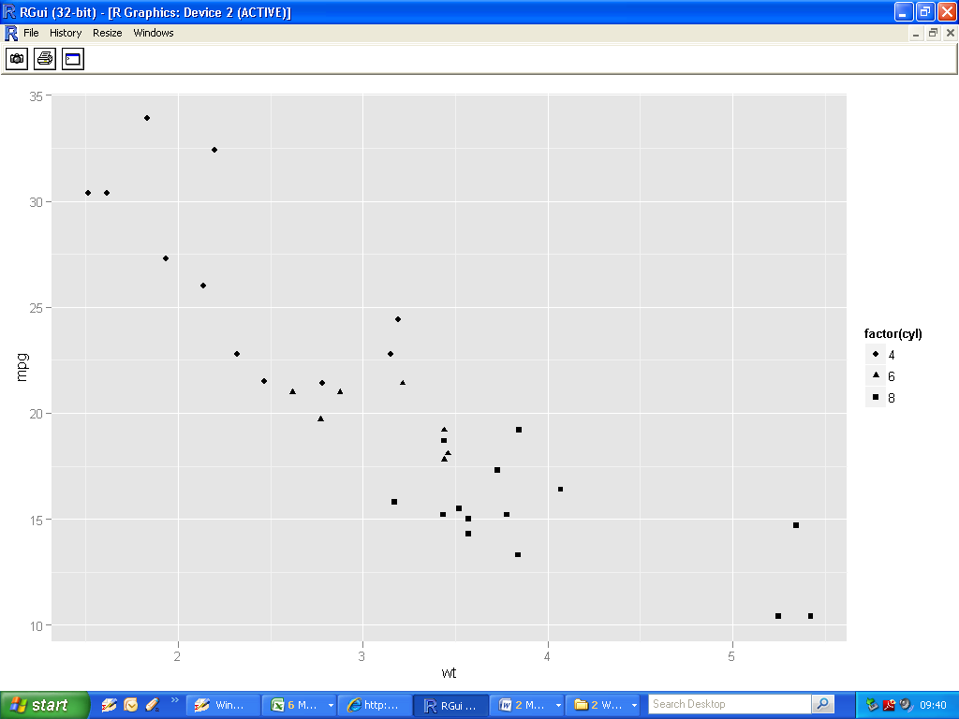

**Using different aesthetic mappings : combinations**

|  |
| --- |
| > qplot(wt, mpg, data=mtcars, **colour=factor(am)**, **shape=factor(cyl)**)  > |

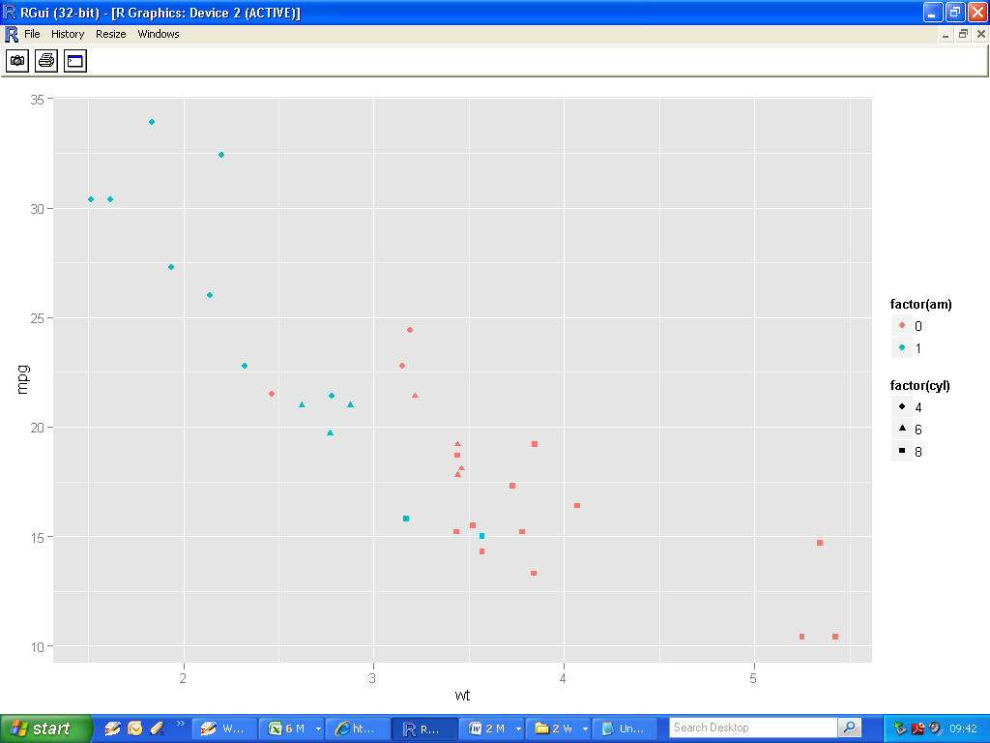

**Using different aesthetic mappings : hollow glyphs**

|  |
| --- |
| > qplot(wt, mpg, data=mtcars, size=qsec, colour=factor(carb), **shape=I(1)**)  > |

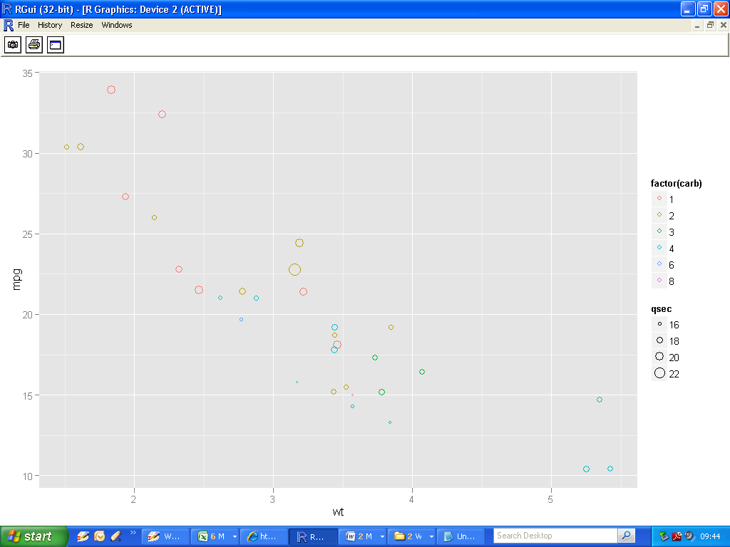

**Barplots and Histograms**

|  |
| --- |
| >qplot(factor(cyl), data=mtcars, geom="bar") |

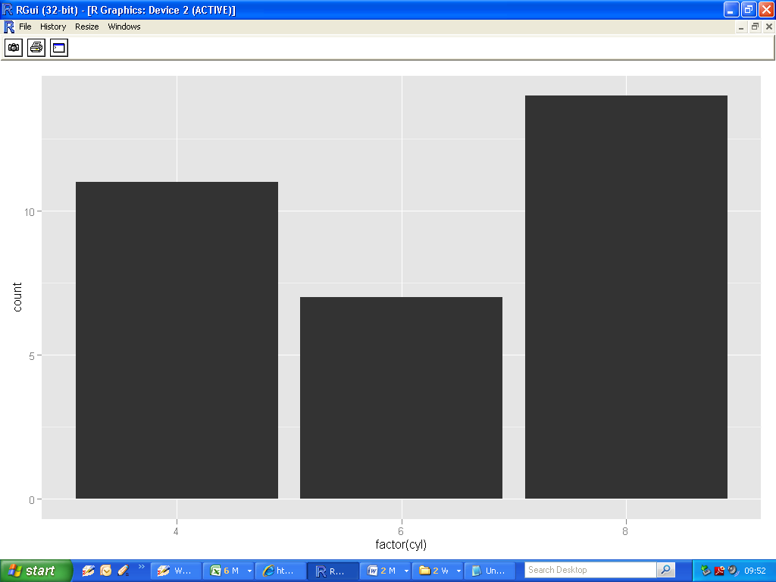

**Barplots: Fill argument**

|  |
| --- |
| >qplot(factor(cyl), data=mtcars, geom="bar", **fill**=factor(cyl))  > |

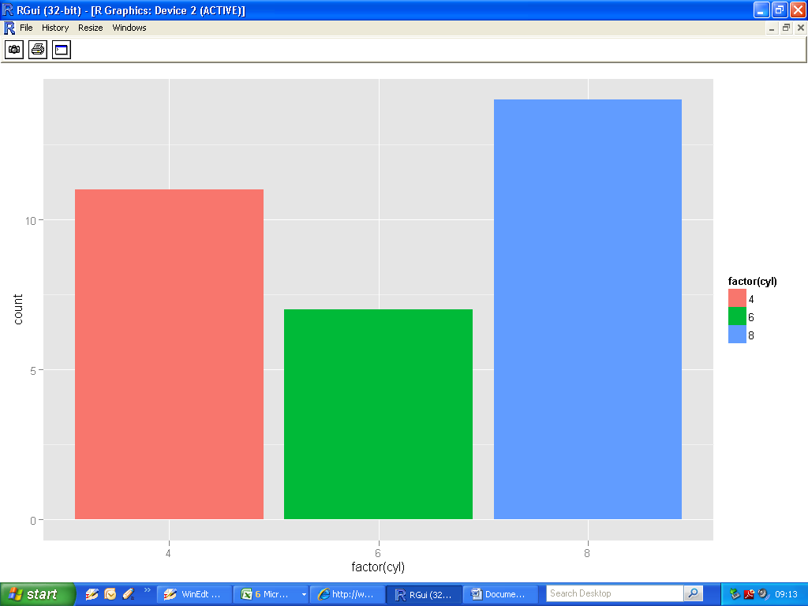

**Barplots: Colour argument (border colouring)**

|  |
| --- |
| > qplot(factor(cyl), data=mtcars, geom="bar", **colour**=factor(cyl))  > |

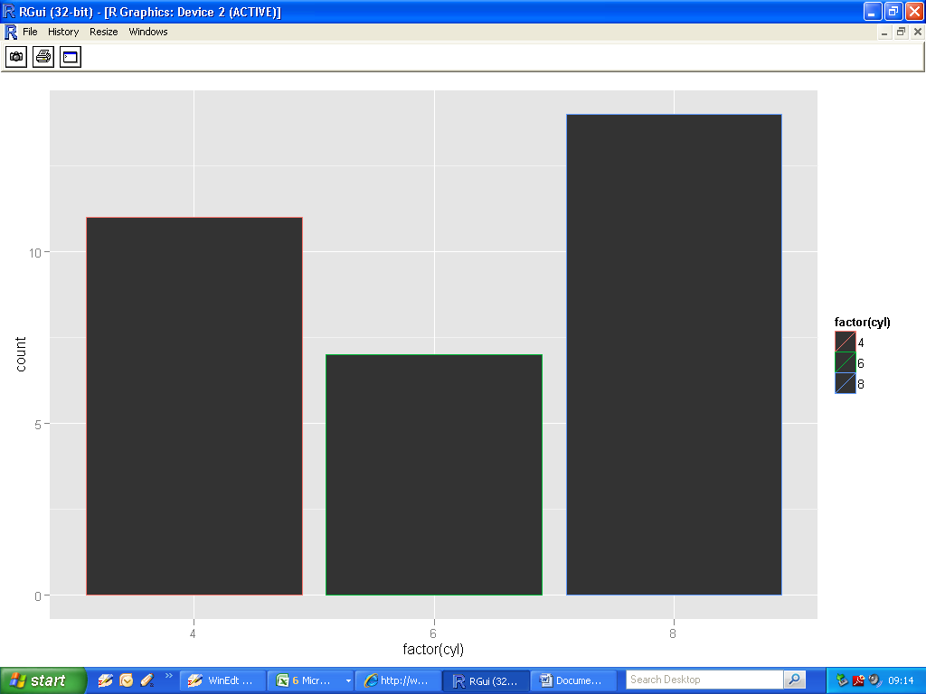

**Flipping a plot onto its side**

|  |
| --- |
| > qplot(factor(cyl), data=mtcars, geom="bar" ,colour=factor(cyl))  + **coord_flip()**  > |

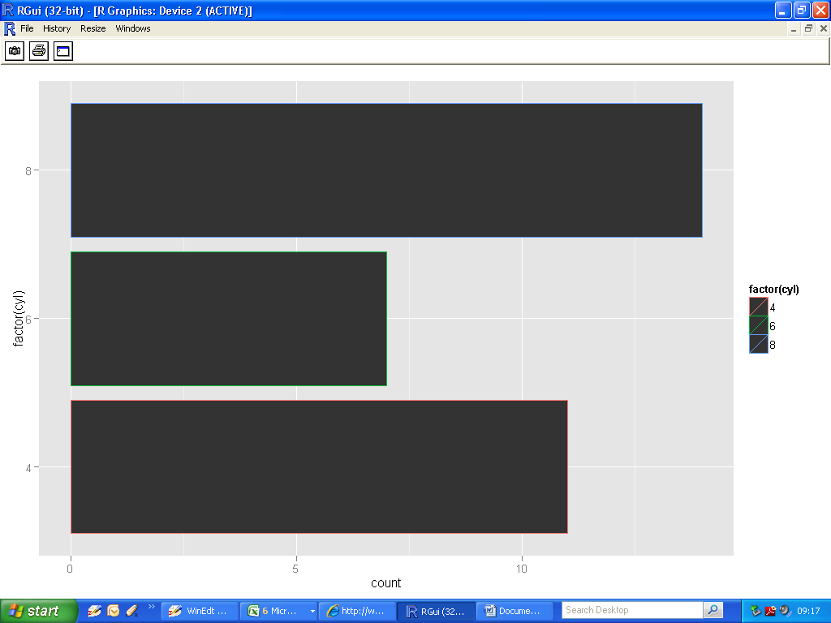

**Scatterplots (using Geoms)**

|  |
| --- |
| >qplot(wt, mpg, data=mtcars, **geom="point"**)  > |

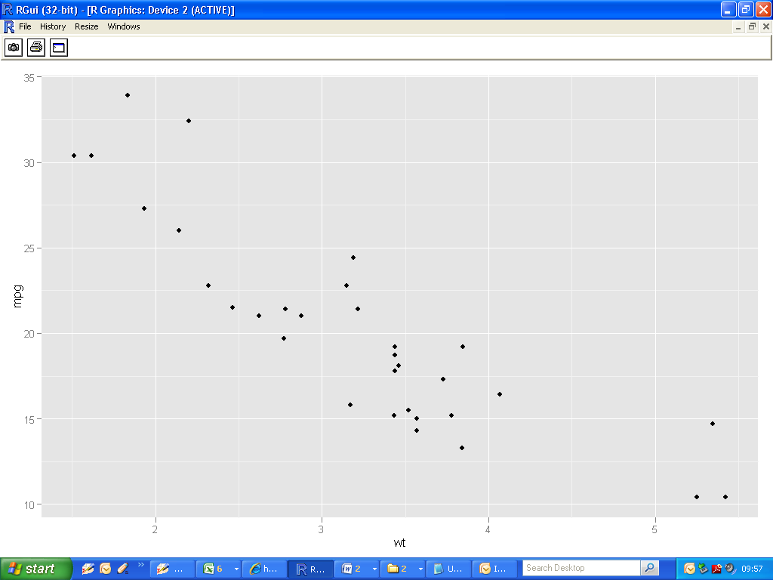

**Smoothing on a Scatterplot (loess smoothing)**

|  |
| --- |
| > qplot(wt, mpg, data=mtcars,  **geom=c("point", "smooth")**)  > |

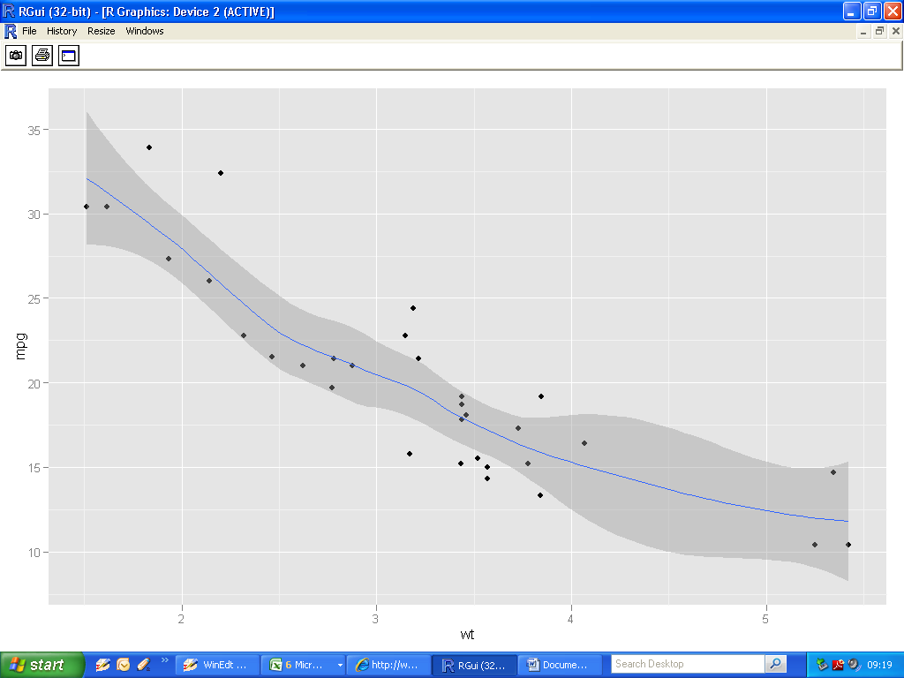

**Removing the standard error from the plot**

|  |
| --- |
| > qplot(wt, mpg, data=mtcars,  geom=c("point", "smooth"),  **se=FALSE**)  > |

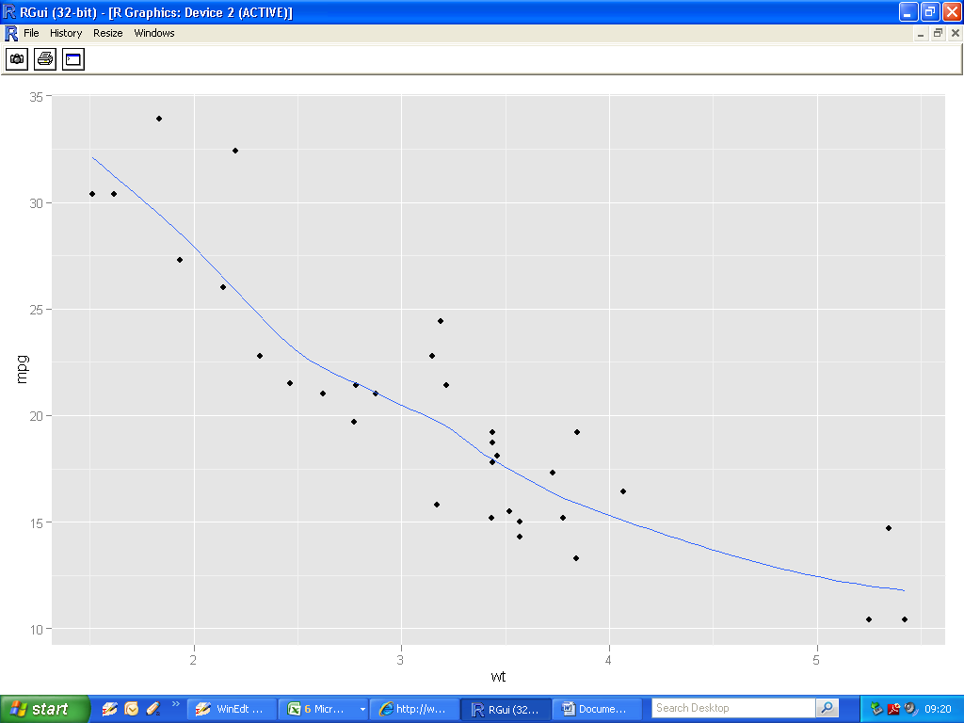

**Linear Modelling**

|  |
| --- |
| > qplot(wt, mpg, data=mtcars,  geom=c("point", "smooth"),  **method="lm")**  > |

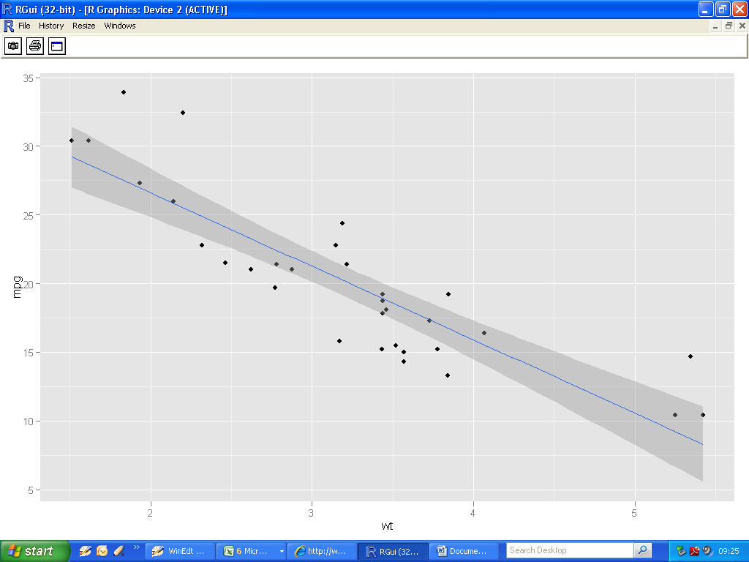

**Facetting**

* **Split into three subplots for each level of cylinder**

|  |
| --- |
| > qplot(mpg, wt, data=mtcars, **facets= cyl~.,** geom=c("point", "smooth")) |

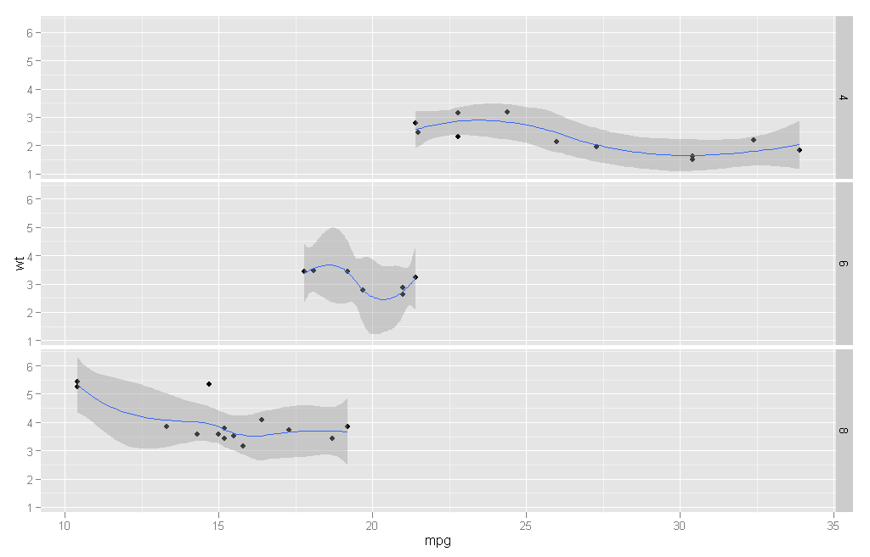

* **Three categories of cylinder : 4, 6 and 8**

**Facetting (example 2)**

|  |
| --- |
| > qplot(mpg, wt, data=mtcars,  **facets=cyl~.**,  geom=c("point", "smooth"),  **method="lm"**)  > |

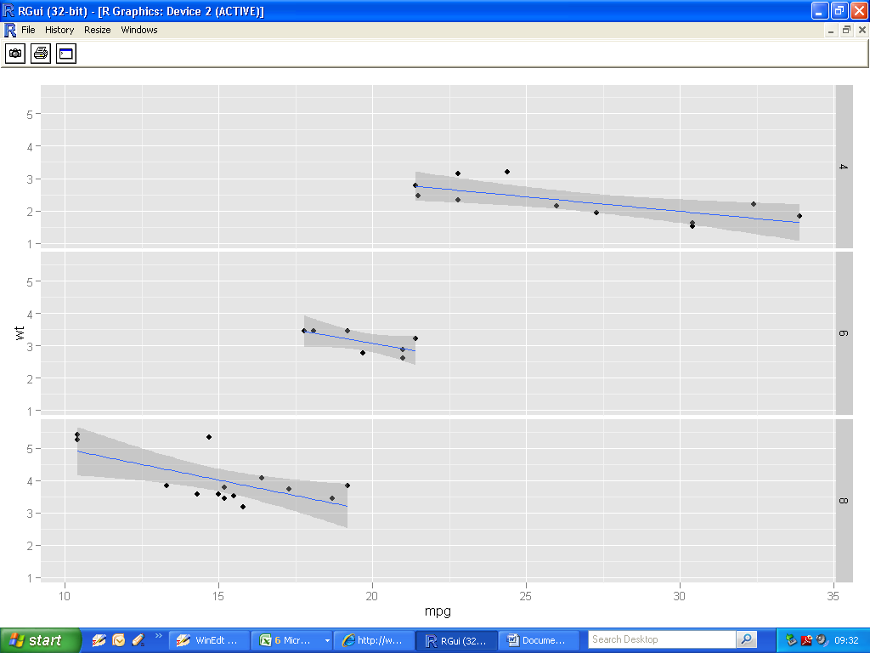

**Diamonds data set**

|  |
| --- |
| > head(diamonds)  carat cut color clarity depth table price x y z  1 0.23 Ideal E SI2 61.5 55 326 3.95 3.98 2.43  2 0.21 Premium E SI1 59.8 61 326 3.89 3.84 2.31  3 0.23 Good E VS1 56.9 65 327 4.05 4.07 2.31  4 0.29 Premium I VS2 62.4 58 334 4.20 4.23 2.63  5 0.31 Good J SI2 63.3 58 335 4.34 4.35 2.75  6 0.24 Very Good J VVS2 62.8 57 336 3.94 3.96 2.48 |

**Different display of bar plots**

|  |
| --- |
| qplot(clarity, data=diamonds, geom="bar", fill=**cut**, position="**stack**")  qplot(clarity, data=diamonds, geom="bar", fill=**cut**, position="**dodge**")  qplot(clarity, data=diamonds, geom="bar", fill=**cut**,  position="**fill**")  qplot(clarity, data=diamonds, geom="bar", fill=**cut**,  position="**identity**") |

## Stack

## 

**2. Dodge**

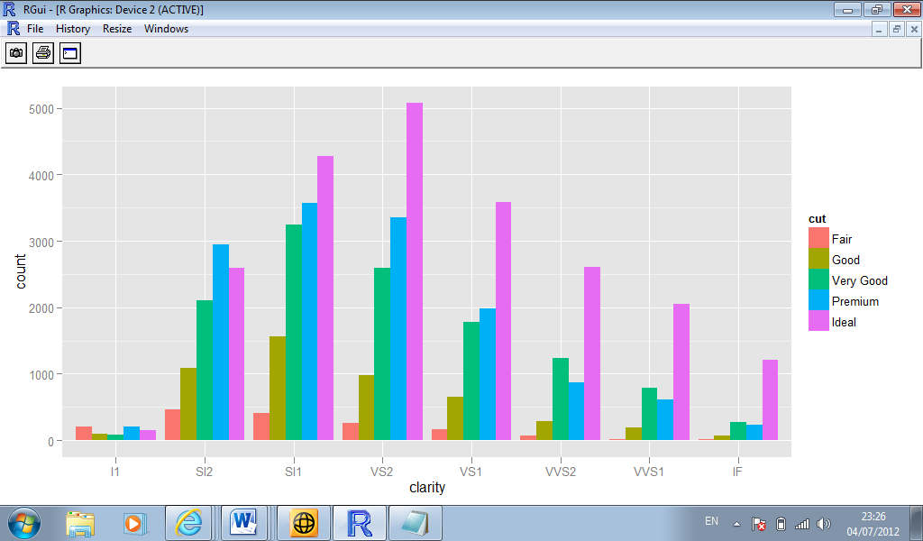

**3. Fill**

## 

**4. Identity**

## 

**Frequency Polygons**

|  |
| --- |
| qplot(clarity, data=diamonds, geom="**freqpoly**", group=cut, colour=cut, position="**identity**")  qplot(clarity, data=diamonds, geom="**freqpoly**", group=cut, colour=cut, position="**stack**") |

## Contingency table

|  |
| --- |
| > table(diamonds$cut,diamonds$clarity)    I1 SI2 SI1 VS2 VS1 VVS2 VVS1 IF  Fair 210 466 408 261 170 69 17 9  Good 96 1081 1560 978 648 286 186 71  Very Good 84 2100 3240 2591 1775 1235 789 268  Premium 205 2949 3575 3357 1989 870 616 230  Ideal 146 2598 4282 5071 3589 2606 2047 1212 |

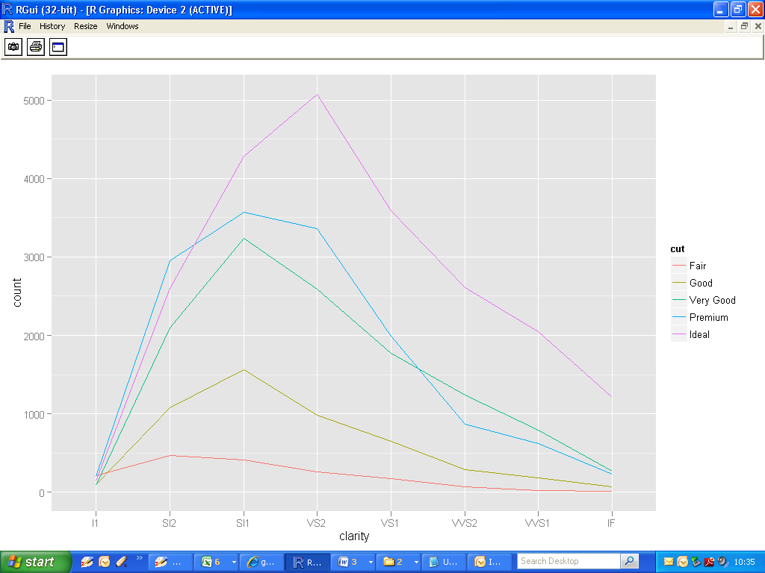

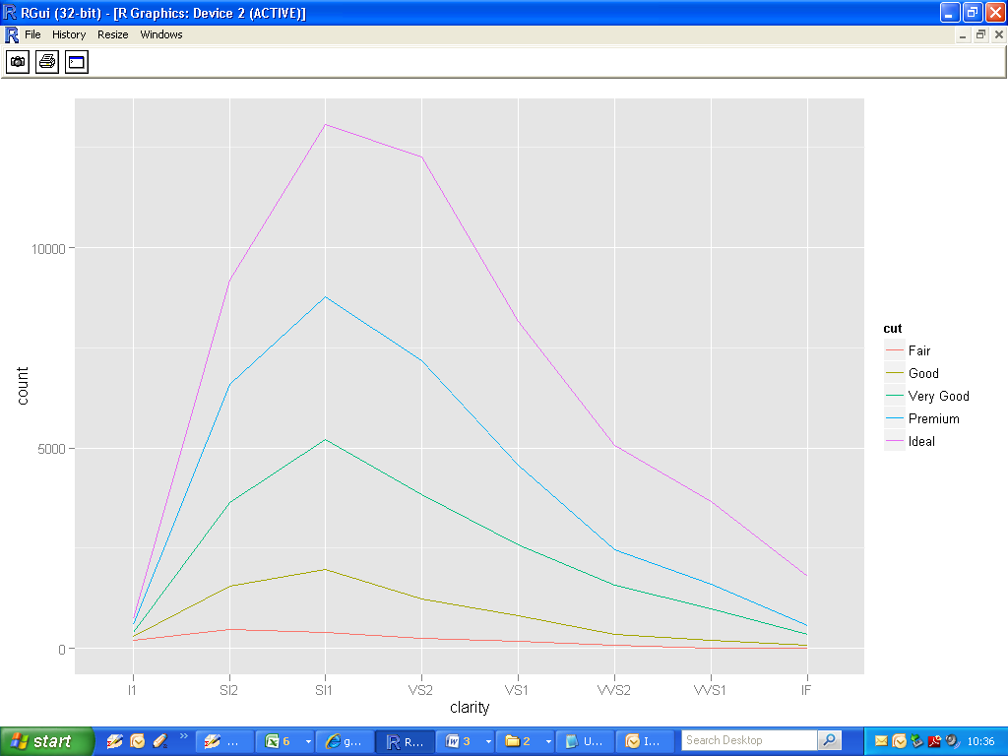

**Palettes**

|  |
| --- |
| >RColorBrewer::display.brewer.all() |

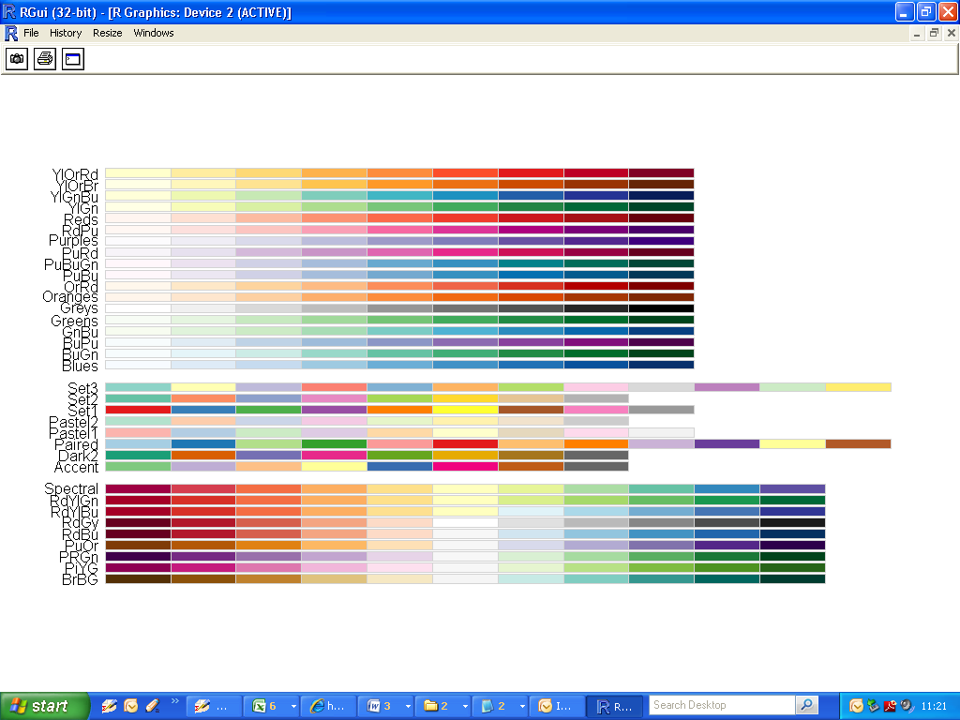

|  |
| --- |
| >QPlot + scale_fill_brewer(palette="Oranges") |

